

Architecture Document for
<Project Name>

.........
This is only a Sample document, for reference purposes and should be considered as an example to help you understand the format and expectations
<Project>-<Component>-AD-<Version>

Table of Contents

1 Introduction 1
1.1 Purpose 1
1.2 Scope 1
1.3 Definitions, Acronyms and Abbreviations 1
1.4 References 1
2 Architectural Goals and Constraints 2
2.1 Reusability 2
2.2 Scalability 2
2.3 Customizability 2
2.4 Extendibility 2
2.5 Use of Existing Business Logic 2
2.6 Time to Market 2
2.7 Portability 2
2.8 Availability 3
2.9 Performance 3
2.10 Any Other Critical Goals Applicable 3
3 Productization Assessment 4
3.1 Re-Usable Components 4
3.2 Analyze Architectural Frameworks in Repository 4
3.3 Identify and Analyze Open Source and COTS Products 4
4 System Architecture 4
4.1 Overview 4
4.2 Logical/Functional View 5
4.3 Use Case View 8
4.4 Implementation/System View 8
4.5 Process/Thread View 9
4.6 Deployment View 9
5 General Architecture for Core Technical Services 11
5.1 Persistence 11
5.2 Inter-process Communication 11
5.3 Authentication and Authorization 11
5.4 Error Handling 11
5.5 Logging 11
5.6 Transaction Management 11
5.7 Other Applicable Technical Services 12
6 Risks/Limitation 13
7 Alternative Solutions Considered 14
Appendix 15
1. Expected Software Response 15
2. Performance Bounds 15
3. Identification of Critical Components 15
4. Review Comments on Architectural POC 15
5. Justification of Changes to Existing Architecture (Optional) 15

Document Revisions
Date | Version | Description | Author

Note: These documents are strictly for specific Virtusa/client use only. They shall not be shared with an external party other than the client concerned. These documents should always be kept securely and employees shall use reasonable care protecting these documents from unauthorized use or disclosure to a third party. This category also covers client intellectual property where Virtusa has a non-disclosure agreement with the client.

Document Approval

Virtusa Corporation and <Client>have reviewed this document and hereby agree that the contents herein are accurate. Any changes to this document must be communicated in writing and signed-off by both parties.

Signature | Signature
Date: | Date:
Name: | Name:
Client: <Client> | Virtusa Corporation

Template User Notes:

Help Info is provided (in blue italics) to describe what each section should contain. Sample Text is provided (in green) in some sections to assist the author in standard wording for common documentation. Macro Buttons (in blue bold italics) must be replaced to match the project, e.g. <Project.

Note: Help Info and Sample Text are included to provide guidance to the author and should be deleted before publishing the document.

Introduction

Purpose
This document provides a comprehensive architectural overview of the Banking Prediction System (Jatayu_Banking_Infras). It outlines the system's core design principles, major components, interactions, and technology choices. The goal is to convey the significant architectural decisions that form the backbone of this system to developers, stakeholders, and future maintainers.

Scope
This POC focuses on building a predictive analytics system that can analyze customer banking behavior and provide insights such as loan default prediction, churn prediction, or service personalization. The project includes data preprocessing, model training, and RESTful API integration for predictions.
Out of scope: Production-level deployment (e.g., CI/CD, scalability), real-time streaming data processing, and integration with third-party financial systems.

Definitions, Acronyms and Abbreviations

Term/Acronym | Definition
POC | Proof of Concept
API | Application Programming Interface
ML | Machine Learning
REST | Representational State Transfer
CSV | Comma-Separated Values
UI | User Interface
DB | Database
Churn | Customer Attrition
Model | Machine Learning Model for Prediction

References

Reference | Description
[1] Scikit-learn Documentation | https://scikit-learn.org/stable/documentation.html
[2] Flask Documentation | https://flask.palletsprojects.com/
[3] Pandas Documentation | https://pandas.pydata.org/docs/
[4] Jatayu_Banking_Infras Git Repository | Internal project source (path in zip: banking_prediction/Jatayu_Banking_Infras/)
[5] Dataset Source | UCI ML Repository or internal mock banking dataset

Architectural Goals and Constraints
This section outlines the architectural requirements, constraints, and assumptions that impact the design of the Banking Prediction System. These goals ensure the system remains robust, maintainable, and adaptable for future enhancements

Reusability
The frontend components and API layers developed in this POC are expected to be reusable in the second phase of development, which will involve integrating a relational database backend (RDBMS). The architecture ensures separation of concerns, enabling reuse of UI and business logic layers with minimal changes.

Scalability
While the current system uses static datasets and a file-based architecture for prototyping, it is designed to support scaling to larger datasets and deployment in a distributed environment. Bottlenecks in data ingestion and model inference will be addressed in future phases with proper storage and compute optimization.

Customizability
The system supports UI theming and configuration of model parameters through external configuration files or an admin panel, enabling non-developer teams to modify behavior and appearance without code changes.

Extendibility
The modular design allows for the addition of new ML models, datasets, or analytics dashboards with minimal refactoring. For example, a new model to predict credit card fraud could be added alongside the existing churn model.

Use of Existing Business Logic
Where applicable, existing financial logic or rule-based decision systems will be modularized into Python packages or REST API services. This ensures maintainability and eases future integration into enterprise systems.

Time to Market
Given the short timeline for this POC, development tools and frameworks (e.g., Flask for backend, Scikit-learn for ML) were chosen for their ease of use and rapid development capabilities. More robust alternatives may be considered for production (e.g., FastAPI, Docker, Kubernetes).

Portability
The system is built with cross-platform compatibility in mind. Python, Flask, and browser-based UI ensure it runs on Windows, Linux, or macOS environments. While the current system uses CSV files, future versions will be portable to databases like PostgreSQL or MySQL with minimal configuration changes.

Availability
As a POC, the system does not guarantee high availability. However, it is structured in a way that can later support uptime guarantees via containerization, load balancers, and replicated services in production environments.

Performance
The model inference pipeline is optimized for small to mid-sized datasets, with response times under 2 seconds for a typical request. Future iterations may include batching, asynchronous processing, or GPU acceleration for real-time analytics.

Any Other Critical Goals Applicable
• Security: Basic input validation and separation of API/public endpoints are included. Future versions will implement user authentication, role-based access, and data encryption.
• Auditability: Predictions and inputs are logged for traceability and future audit requirements.
• Compliance: The system is designed to comply with data privacy guidelines (e.g., anonymization of personally identifiable data in training datasets).

Productization Assessment

Re-Usable Components
The following reusable components have been identified through productization analysis:

Component | Description | Reusability Scope
Prediction API Layer | A RESTful API built using Flask to serve predictions from ML models | Can be reused across other predictive analytics solutions
Data Preprocessing Module | Functions for cleaning, encoding, and scaling data | General-purpose module for any ML model involving tabular financial data
Model Training Pipeline | A standardized script for model training, evaluation, and export | Reusable across multiple models by adjusting configurations
UI Dashboard | Frontend components for displaying prediction results and insights | Reusable in future financial applications with minor adjustments
Logging and Monitoring Utilities | Basic logging setup for tracking requests and responses | Can be extended into a centralized monitoring solution

Commonality Analysis:
The API, data pipeline, and UI components share a common architecture built around modularity and configuration-driven design.
Variability Analysis:
- The ML model may vary depending on the use case (e.g., churn, default, fraud).
- Input features and schema will change per banking service.
- UI visuals can be themed or extended with additional charts and analytics.

Analyze Architectural Frameworks in Repository
The architecture leverages modular Python-based frameworks that enable rapid development and plug-and-play capabilities:

Framework | Usage | Reusability Potential
Flask | Backend API server | High – can be adapted for other ML model services
Scikit-learn | Model training and inference | High – reusable across most supervised learning tasks
Pandas | Data transformation | High – core to data engineering across projects
Plotly/Dash (if present) | UI Visualization | Moderate – can be templated for reusable analytics dashboards

These frameworks align with common software practices and can be standardized into internal templates or starter kits.

Identify and Analyze Open Source and COTS Products
Below is an overview of the open-source and potential commercial off-the-shelf (COTS) software components used:

Product | Type | License | Legal Consideration
Python | Open Source | PSF License | Approved for commercial use
Flask | Open Source | BSD-3-Clause | No restrictions for reuse
Scikit-learn | Open Source | BSD | Approved; attribution required
Pandas | Open Source | BSD | No known legal issues
NumPy | Open Source | BSD | Widely used, no restrictions
Matplotlib/Plotly | Open Source | MIT (Plotly), PSF (Matplotlib) | Approved, ensure UI code respects license terms

System Architecture

The Banking Prediction System follows a three-tiered architecture comprising UI Services, Business Services, and Data Services. Each tier is designed for separation of concerns and modularity, allowing independent development, testing, and scaling.
Models | XML compliant tool
Diagrams | .png format

Overview

The application is composed of several core architectural components, divided into distinct layers:
- User Interface Services: Responsible for receiving input and presenting output to users via a dashboard or command-line interface.
- Business Services: Hosts the prediction logic, ML models, and core API routes.
- Data Services: Manages the loading, preprocessing, and serving of banking datasets.
Each layer interacts only through defined interfaces (e.g., REST APIs, serialized model files), enabling modularity and future substitution.

Logical/Functional View
Below is a high-level logical view of the system architecture:
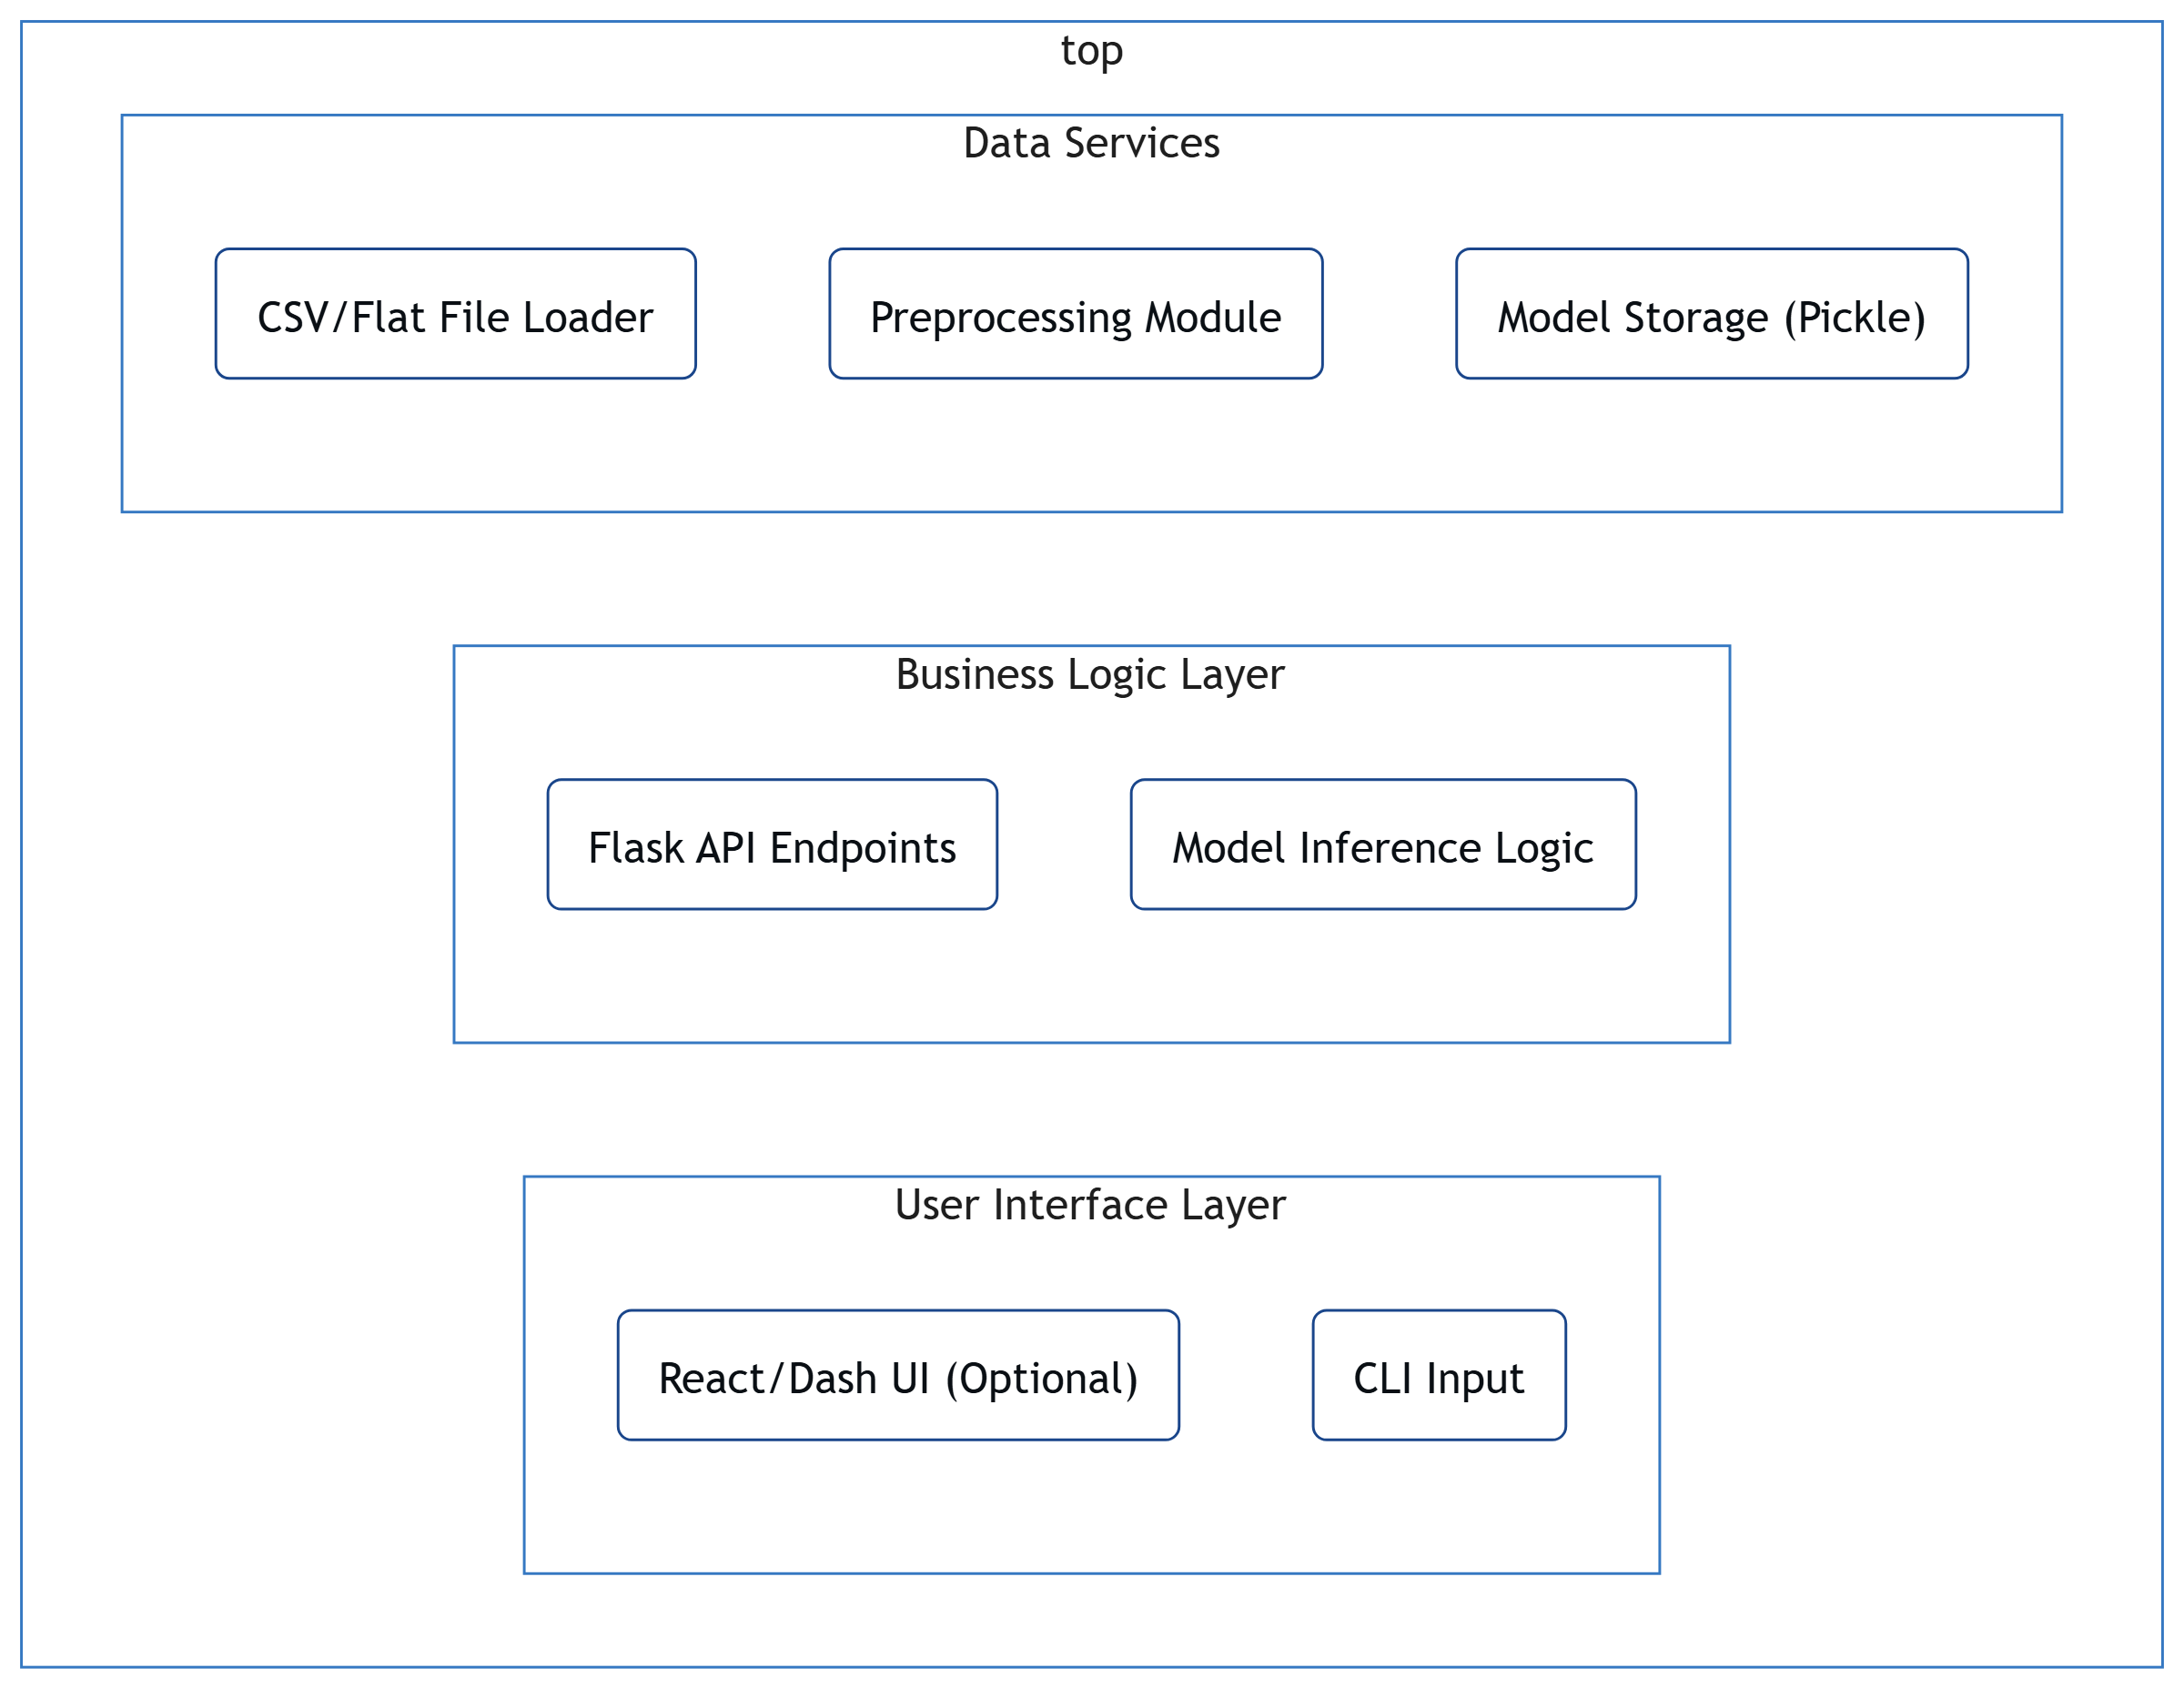

Logical Components:
- UI Layer: Form inputs, JSON responses, basic visualizations (if Dash or Plotly used)
- Business Logic Layer: ML prediction services, response formatting, logging
- Data Layer: Raw data loaders, transformation utilities, model file access
Option 1: (Example Use block diagrams)

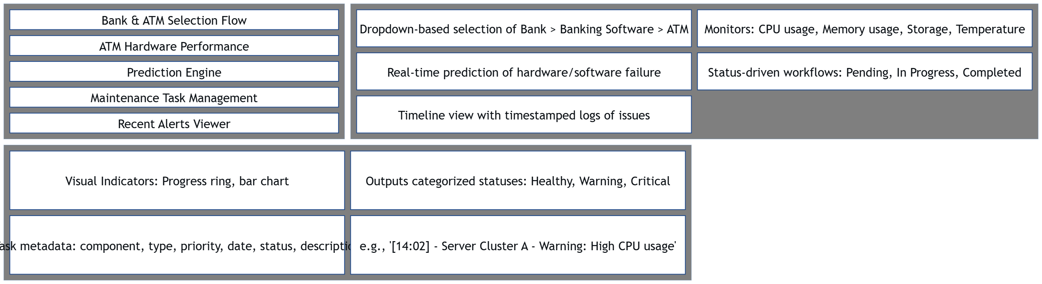

FIGURE 1: Sample Project Application Architecture Overview
Option 2: Package and Layering Diagram (preferred)

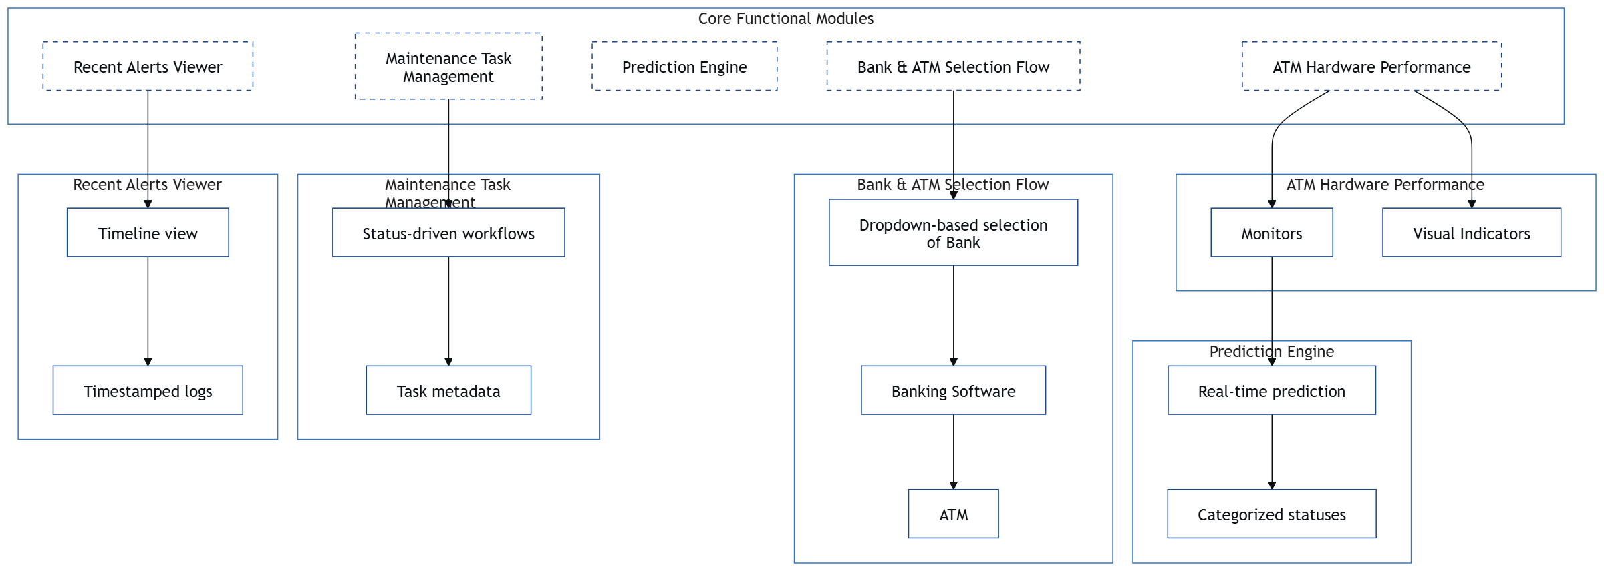

The application is divided into three tiers: User Interfaces Services, Business Services and Data Services. Each layer is responsible for handling a well-defined area of the application.

Use Case View

- Use Case 1: Monitor ATM Infrastructure
- Actor: System Admin
- Goal: Monitor ATM hardware metrics in real-time
- Steps:
  - Select Bank & ATM
  - View CPU, memory, storage, temperature stats
  - Evaluate prediction status (Healthy/Warning/Critical)
- Use Case 2: Receive Maintenance Alerts
- Actor: Maintenance Team
- Goal: Take proactive actions based on predictive alerts
- Steps:
  - Receive alert via timestamped logs
  - View status chips (Warning/Critical)
  - Assign and update maintenance tasks (Pending → In Progress → Completed).
- Use Case 3: Plan Maintenance Tasks
- Actor: Infrastructure Manager
- Goal: Plan tasks based on future failure predictions
- Steps:
  - Review prediction output
  - Create maintenance task
  - Track progress using badges (Pending/In Progress/Completed).

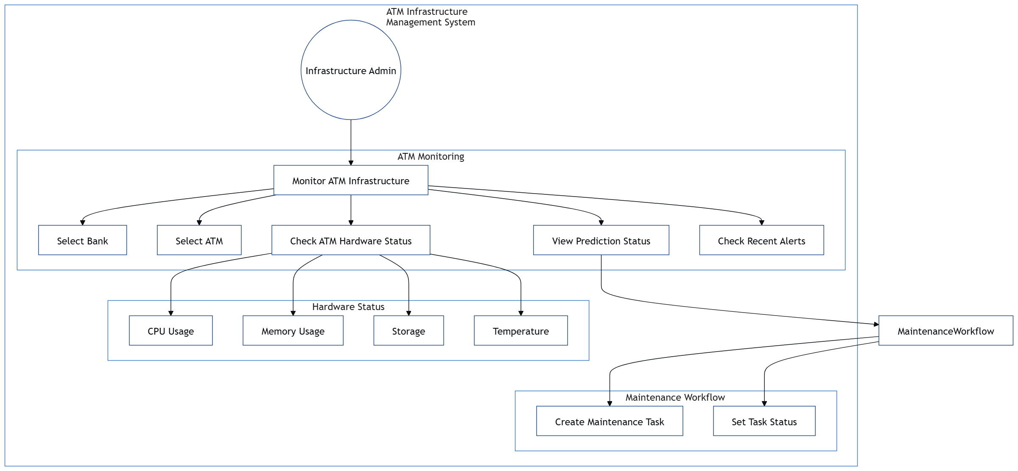

Implementation/System View
Key Modules and Structure:
- app.py – Flask application serving prediction APIs
- preprocessing.py – Data transformation logic
- model/ – Contains saved .pkl or .joblib model files
- data/ – Sample flat files (CSV)
- utils/ – Logging, config reading, exception handling

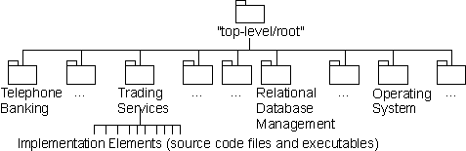

Process/Thread View

Typical Flow:
- User uploads data via UI/API
- Flask Server receives request
- Preprocessing Module transforms input data
- ML Model loads and performs prediction
- Response is returned as JSON
This is a sequential process, with optional multithreading for handling concurrent API calls. In production, this would be managed with a WSGI server like Gunicorn.
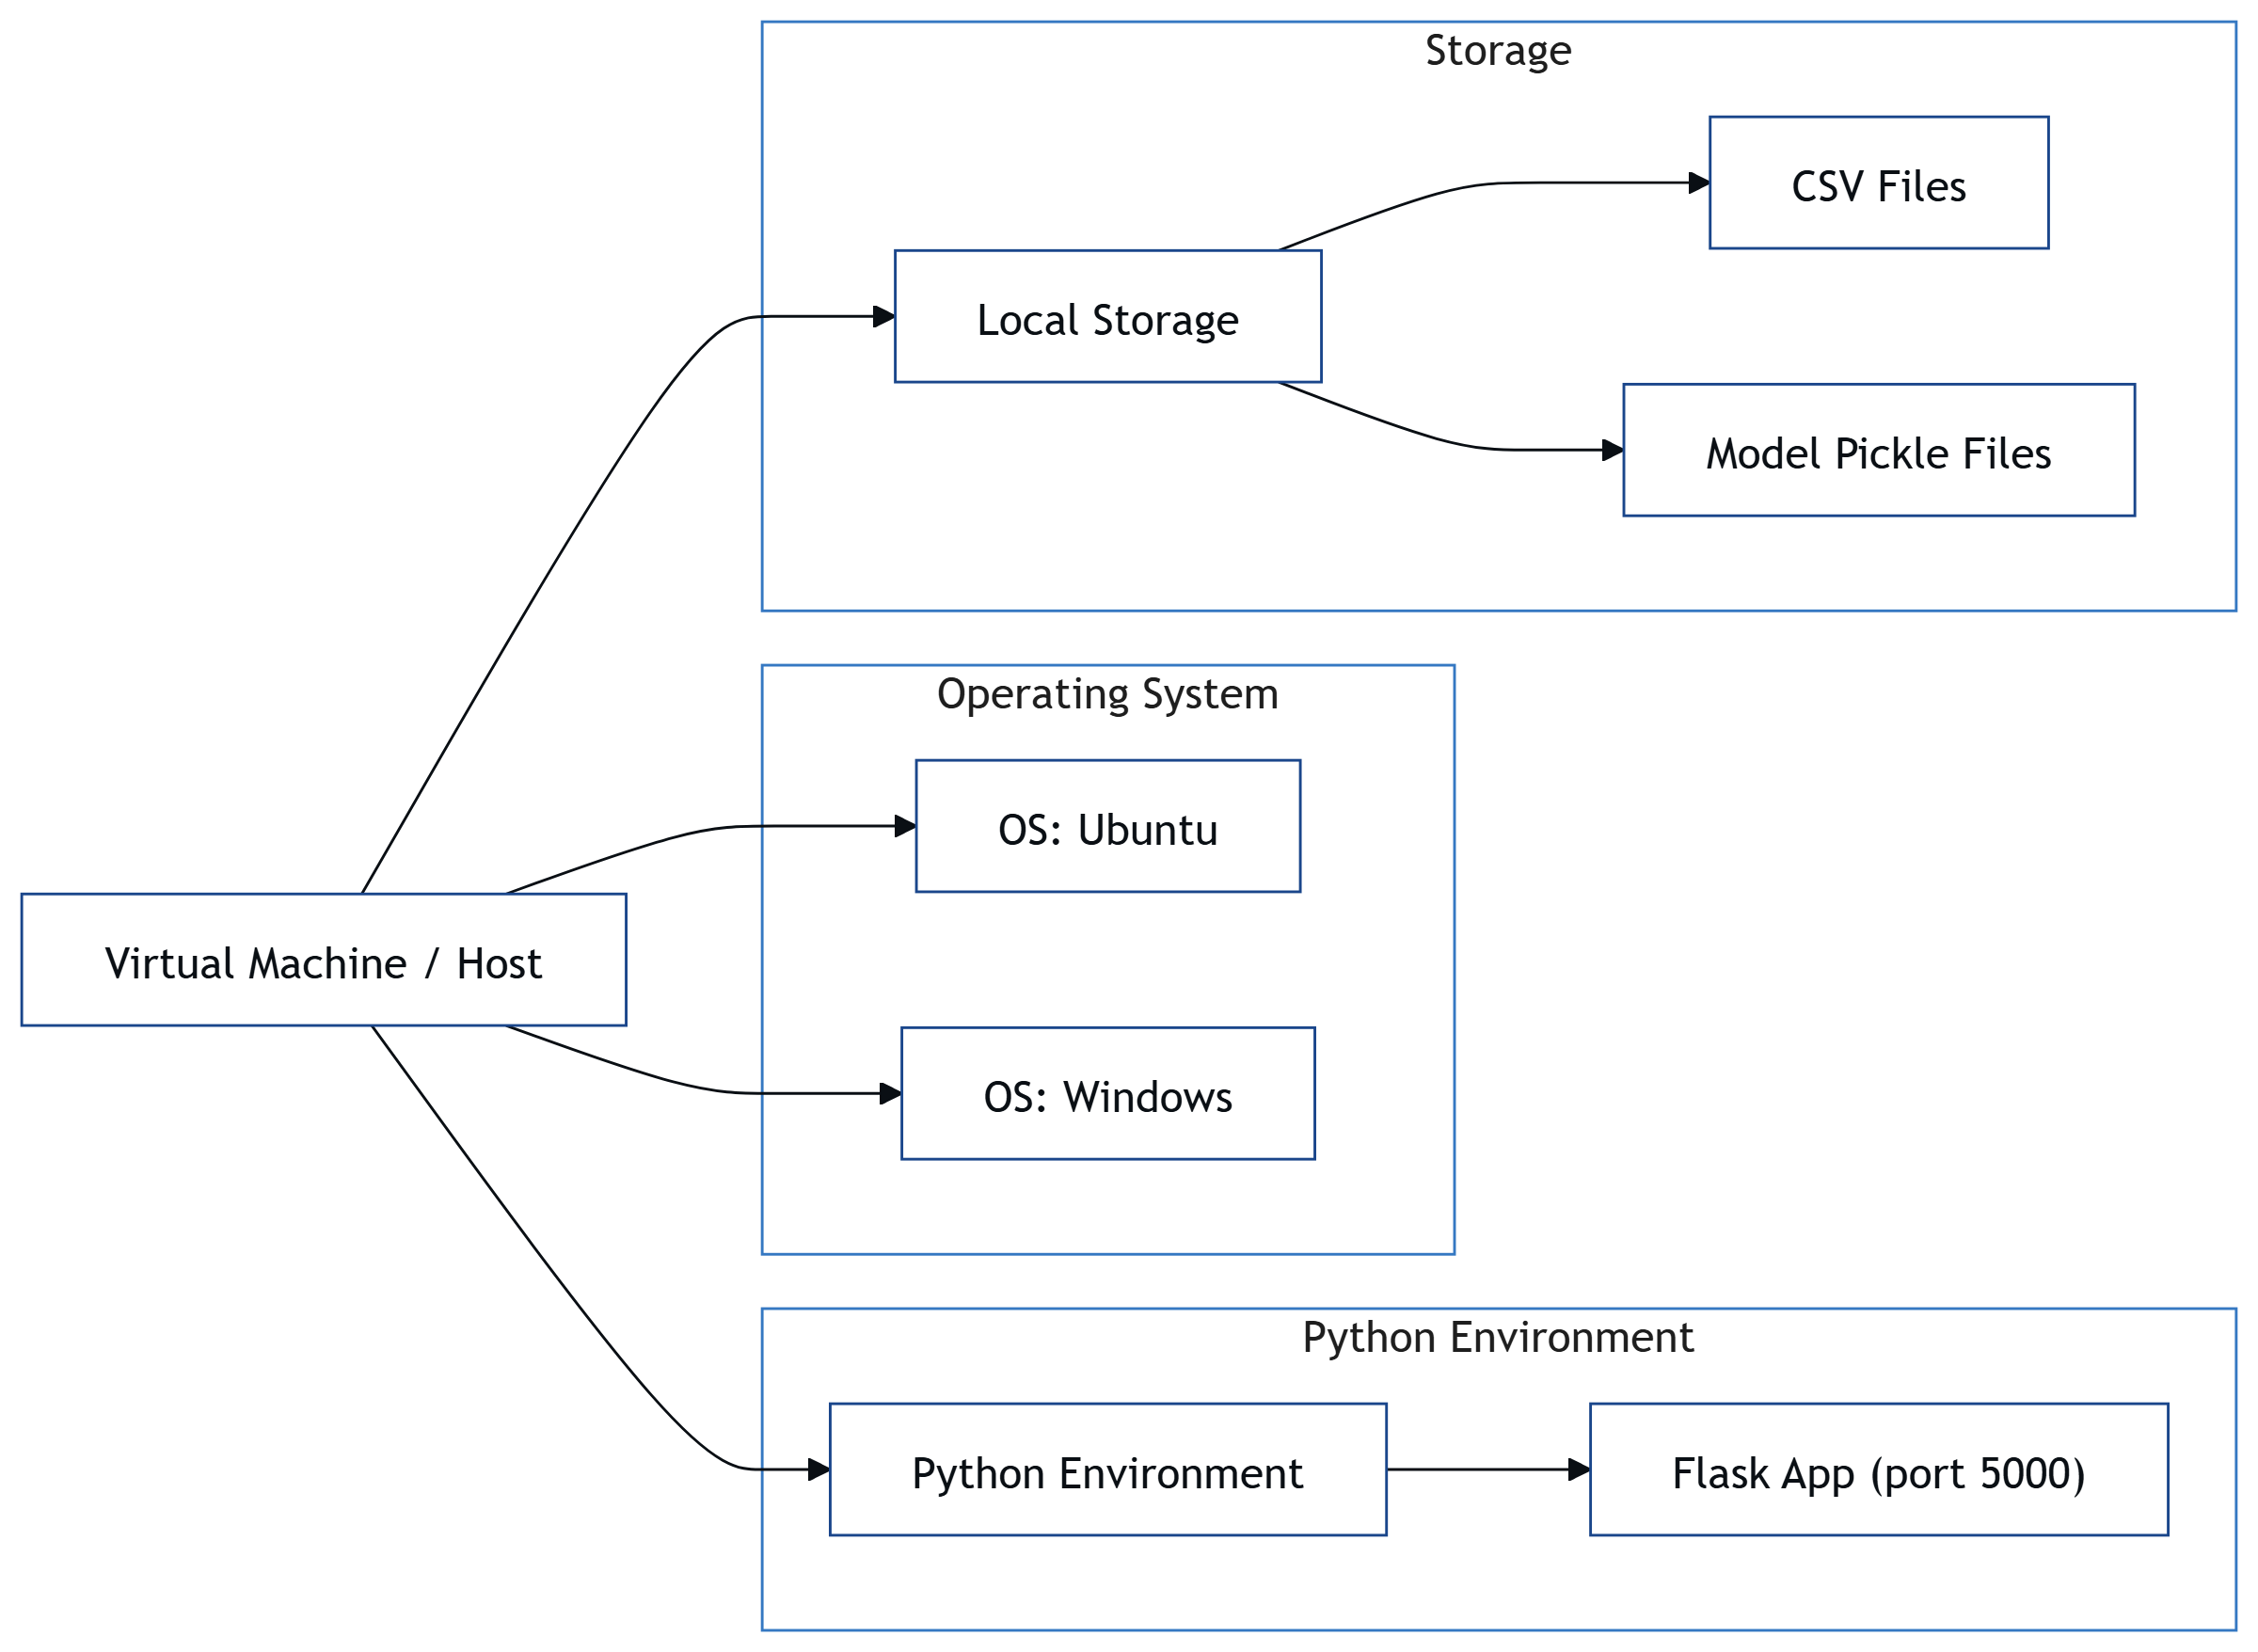

Deployment View

The Deployment View represents the physical architecture and infrastructure setup on which the Jatayu Banking Infrastructure Monitoring System is deployed and executed. It maps software components to hardware nodes and shows the communication between these components in a real-world environment.

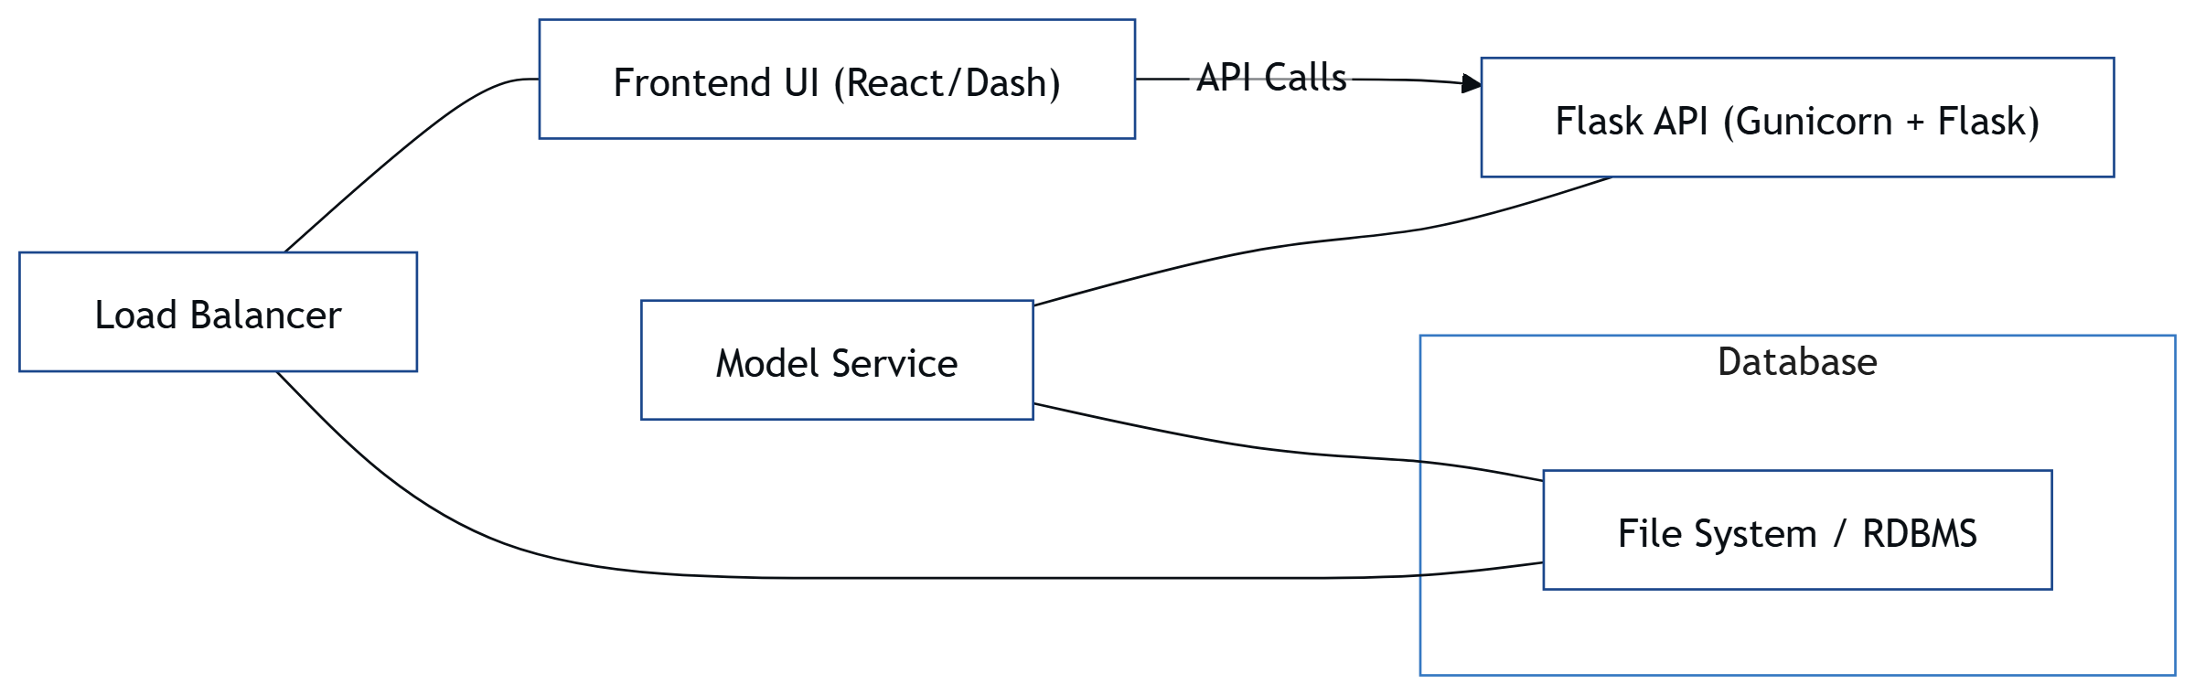

General Architecture for Core Technical Services

This section outlines the architectural strategies and key decisions for implementing core technical services such as persistence, communication, security, logging, and more. The analysis includes trade-offs, alternative solutions considered, and decisions on whether to build, buy, or reuse components.

Persistence
Strategy: A centralized database (e.g., MongoDB or PostgreSQL) stores banking metadata, ATM performance metrics, prediction results, alert logs, and maintenance task statuses.
Trade-offs:
- Relational DBs offer structured queries and ACID compliance but have limited flexibility for hierarchical monitoring logs.
- NoSQL DBs offer scalability and flexibility for semi-structured logs but may compromise transactional integrity.
Decision: MongoDB was chosen for its ease of storing nested documents (e.g., timestamped hardware stats).
Build/Buy/Reuse: Open-source MongoDB reused with Mongoose ORM (Node.js) or equivalent.

Inter-process Communication
Strategy: RESTful APIs between client, server, and ML prediction module; optionally MQTT or gRPC for telemetry ingestion from ATM agents.
Trade-offs:
- REST APIs are easy to manage and integrate but introduce latency for real-time updates.
- MQTT/gRPC are better suited for high-frequency telemetry data from edge devices.
Decision: REST API for UI-to-backend and backend-to-ML service; MQTT considered for ATM-to-server streaming.
Build/Buy/Reuse: Reused existing open-source MQTT brokers (e.g., Mosquitto); custom-built REST APIs.

Authentication and Authorization
Strategy: Use OAuth 2.0 or JWT-based token authentication for client access. Role-based access control (RBAC) enforced at backend.
Trade-offs:
- OAuth is secure but requires setup with third-party identity providers.
- JWT is stateless and lightweight but tokens must be securely managed and expired.
Decision: JWT for internal authentication; scoped access for admin vs. viewer roles.
Build/Buy/Reuse: JWT libraries reused; possible integration with enterprise IAM in future.

Error Handling
Strategy: Centralized error-handling middleware to capture client, backend, and ML service errors. Categorized into user errors, system faults, and hardware alerts.
Trade-offs:
- Centralized error logging simplifies debugging but may miss edge-case UI errors.
Decision: Implement backend middleware error handler and frontend try/catch + error boundaries.
Build/Buy/Reuse: Built in-house with reuse of error-handling middleware from Express (Node.js).

Logging
Strategy: Use structured logging (JSON) with log levels (info, warning, critical) and correlation IDs for tracing transactions.
Trade-offs:
- Real-time logging may burden the system unless buffered or offloaded.
Decision: Use Winston (Node.js) or Python logging module; logs pushed to ELK stack (Elasticsearch, Logstash, Kibana).
Build/Buy/Reuse: Reused open-source logging libraries; centralized log viewer (Kibana).

Transaction Management
Strategy: Ensure atomic updates when handling status transitions (e.g., maintenance task status: Pending → In Progress → Completed).
Trade-offs:
- MongoDB lacks traditional ACID transaction support across multiple collections.
Decision: Use single-document updates where possible; fallback to two-phase commit or retry logic for multi-step operations.
Build/Buy/Reuse: Custom implementation using MongoDB's transaction API (if using replica sets).

Other Applicable Technical Services
• Installation Mechanism: Containerized deployment using Docker; optionally Helm charts for Kubernetes.
• Failure Prevention/Fault Tolerance: Use watchdog agents and heartbeat checks from ATM hardware; automatic retry logic on failures.
• Caching Design: In-memory caching (Redis) for recent alerts and bank/ATM dropdown data.
• Internationalization: Placeholder hooks in UI for i18n; English as default language.
• Validation Framework: Backend input validation using Joi or Pydantic; UI form validation for dropdowns and actions.
• Client and Server Initialization: Use systemd or PM2 for backend services; pre-loading configs and DB schemas at startup.

Risks/Limitation
The following risks and limitations were identified during the architectural design phase:
- Hardware Dependency: System relies on consistent telemetry data from ATMs; outdated or faulty hardware may lead to inaccurate predictions.
- Scalability Concerns: Initial deployment may handle limited ATM clusters; performance may degrade as more banks/ATMs are added without proper load balancing.
- Security Risks: Real-time data flowing from distributed ATMs to central servers could be a vector for interception or tampering if not properly encrypted.
- Data Quality: Machine learning predictions depend heavily on the quality of historical performance data. Poor or sparse data can reduce accuracy.
- Legal and Compliance: Usage of monitoring data across banking institutions may raise privacy or data sharing concerns, especially without formal agreements.
- Limited Offline Support: The system requires constant network connectivity for real-time monitoring and alerting. Offline operation is limited.

Alternative Solutions Considered
During the design phase, several alternative architectural solutions were considered:
7.1 Monolithic vs. Microservices Architecture
- Considered: Microservices-based design for independent deployment of prediction, alerting, and logging modules.
- Decision: A semi-modular monolithic architecture was chosen for simplicity and faster deployment, with scope for future decomposition.
7.2 MQTT vs. REST for Telemetry
- Considered: MQTT for lightweight, real-time telemetry; REST for traditional request-response.
- Decision: REST APIs implemented for flexibility and ease of integration with web clients. MQTT deferred to future versions for real-time ingestion.
7.3 Self-hosted vs. Cloud-hosted Infrastructure
- Considered: Deploying on AWS/GCP vs. on-premises data centers.
- Decision: On-premises servers preferred initially due to data sensitivity, with the possibility to migrate to cloud as demand scales.
7.4 Prediction Model In-House vs. Third-party ML-as-a-Service
- Considered: Google Vertex AI or Azure ML vs. in-house PyTorch model.
- Decision: In-house Wav2Vec2-based model used for full control and customization over prediction logic.

Appendix

[Present information that supplements the architecture specification.]

Expected Software Response
When an ATM crosses temperature or CPU usage thresholds, an alert should be raised within 2 seconds.
Maintenance tasks marked as Completed should be reflected in the dashboard within 5 seconds.
Dropdown selections for banks and ATMs should update dependent fields without page refresh.

Performance Bounds

Latency: Alerts should be generated and displayed within 2–3 seconds of receiving telemetry data.
Prediction Response Time: ML model inference must complete within 1 second for each ATM input.
Dashboard Refresh Rate: Real-time dashboards update every 10 seconds.
System Uptime: Target uptime is 99.5% per month.

Identification of Critical Components

Prediction Module: Core to health classification of ATM devices.
Alert Engine: Responsible for notifying staff of hardware issues.
Data Ingestion Layer: Faults in this component can disrupt monitoring across all ATMs.
Maintenance Tracker: Maps real-world actions with software logs.

Review Comments on Architectural POC

The architectural proof-of-concept (POC) demonstrated feasibility for real-time alerts.
Suggestions:
- Improve latency by optimizing API response times.
- Refactor monolithic structure for long-term microservices transition.
- Incorporate user-based permission levels for different dashboard views.

Justification of Changes to Existing Architecture (Optional)

The existing single-layer dashboard was restructured into a three-tier model to clearly separate UI, business logic, and data services.
Real-time prediction was separated from alerting logic for better fault isolation.
Added support for external alert streaming to third-party systems (e.g., email, SMS gateways).

